**Deploy an Application on a Platform-as-a-Service Cloud**

**(Etherpad / Etherpad-Lite on PaaS)**

1. Open the following link: <https://www-947.ibm.com/account/userservices/jsp/login.jsp?persistPage=true&page=/FIM/sps/IBM_WWW_SAML20_EXTERNAL/saml20/logininitial%3FRequestBinding%3DHTTPPost%26ResponseBinding%3DHTTPPost%26NameIdFormat%3DEmail%26PartnerId%3Dhttps%3A//idaas.ng.bluemix.net/sps/saml20sp/saml20&PD-REFERER=https://idaas.ng.bluemix.net/idaas/public/tamlogin.jsp&error>=
2. Once you login, you get to see the following page:

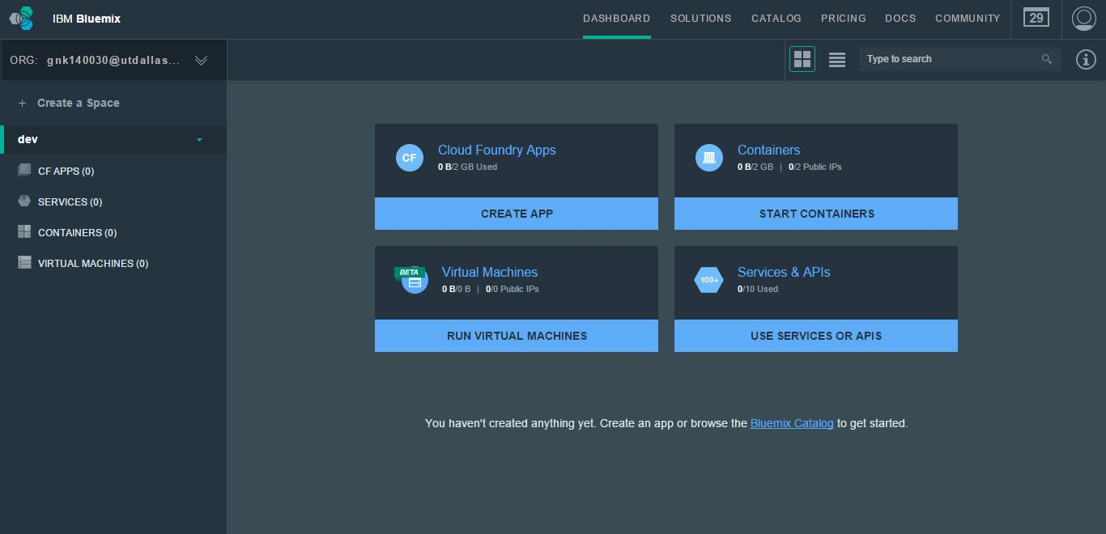

1. Once you enter the page above, click on CREATE APP option under Cloud Foundry Apps. It will lead you to a new page as shown:

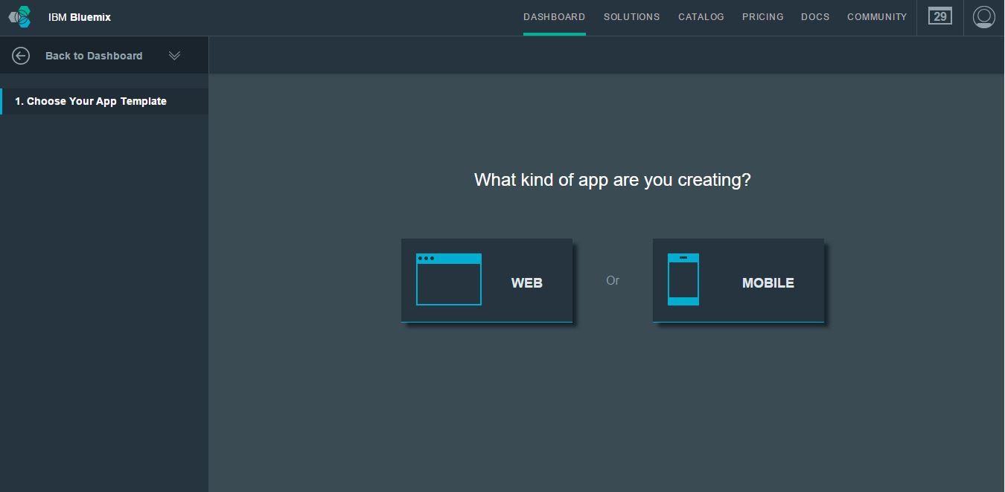

1. We are creating a web application. So click on it and it leads to a new page where you need to select SDK for Node.js and click Continue as shown below:

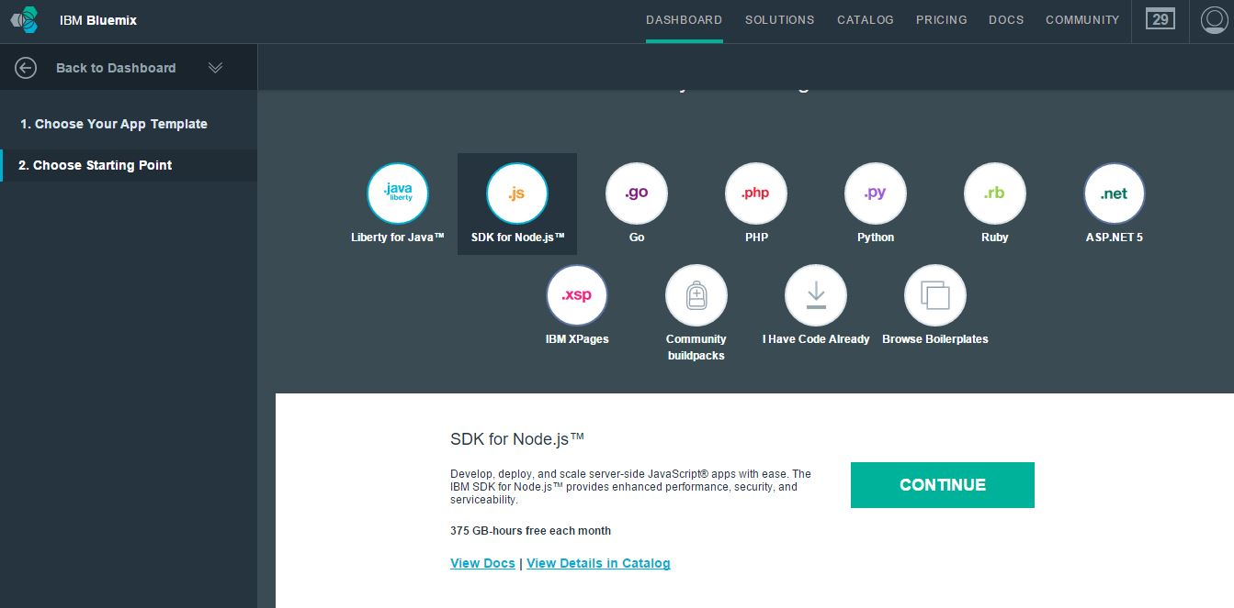

1. You need to give a name for the application that you are building. I named our application as Etherpad2015_gayathri.
2. Once the application starts running, Download the CF Command Line Interface to deploy and modify application and service instances.

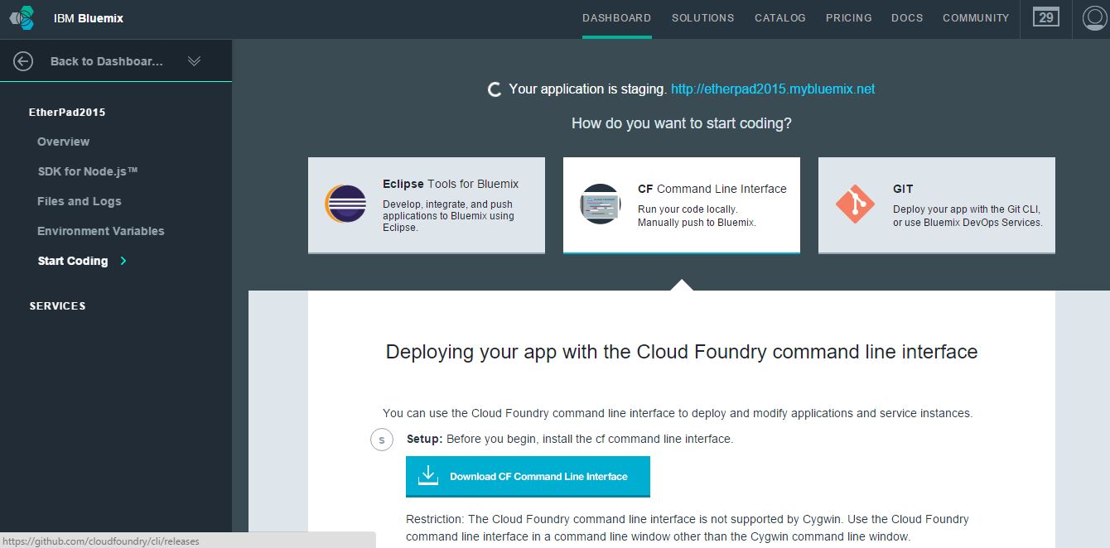

1. Now download the Windows-64bit CF version in the Installers and After the CF command line interface is installed, you can get started by downloading the etherpad-lite-cf.zip and extract the package to a new directory to set up the development environment.
2. Next, open the command prompt and follow the following commands:

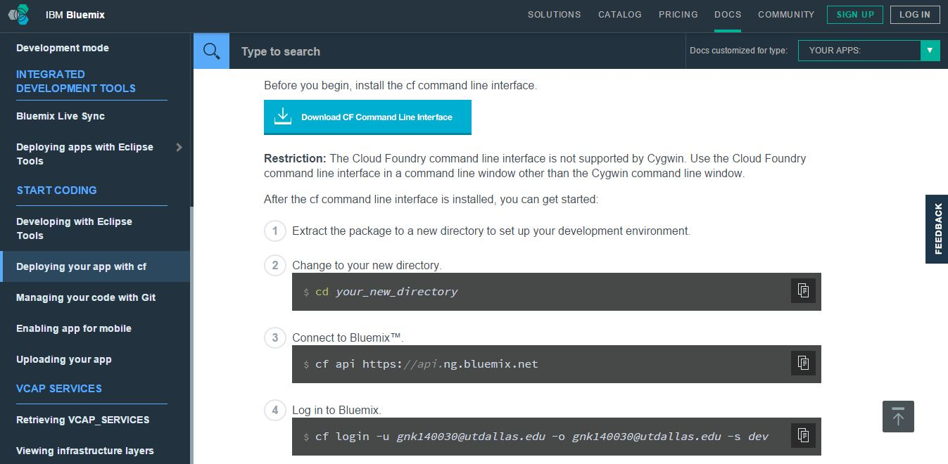

1. The next step is pushing the app to Bluemix:

cf push Etherpad2015_gayathri -m 512M -b <https://github.com/cloudfoundry/nodejs-buildpack.git>

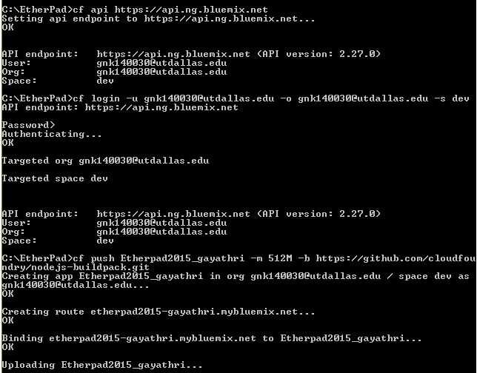

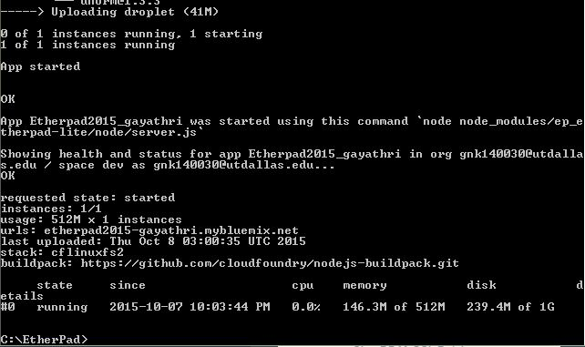

1. Next, we need to create a service to allow Etherpad to connect to our database.  To do that, let’s go back to the Bluemix UI.  In the top click on Dashboard, you should see the app you created.  Let’s go ahead and click on it. To add the service Bluemix will provision and bind a service to our app for us.  Click “Add A Service” and scroll down to data management.  We want ClearDB for this app.  Click on ClearDB and click “Create”. Now, It will ask if you want to restage the app, so click RESTAGE.
2. **Configure the app with ClearDB (MySQL):**

To switch the app over to MySQL, we need to edit the settings.json for the app and then re-upload the app to Bluemix. You will need to replace the value DATABASE with the name of your ClearDB service.  To get this info, let’s go back to the Bluemix UI and our app.  If you click on “Show Credentials”, it will give you the name of your ClearDB service, copy and paste this in the settings.json file and save the file:

"dbService": "ClearDB MySQL Database-by",

1. The last step is re-pushing our app to Bluemix since we made a change to it.  To do this we need to use the push command we used above:

cf push Etherpad2015_gayathri -m 512M -b <https://github.com/cloudfoundry/nodejs-buildpack.git>

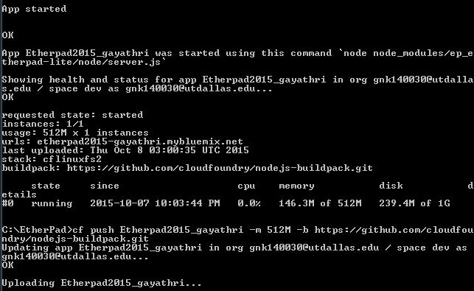

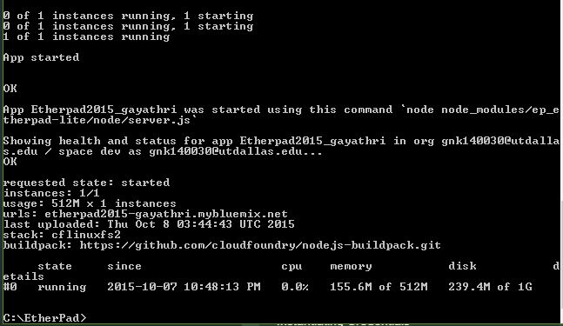

1. Now, open the link provided in the dashboard:

http://etherpad2015-gayathri.mybluemix.net/

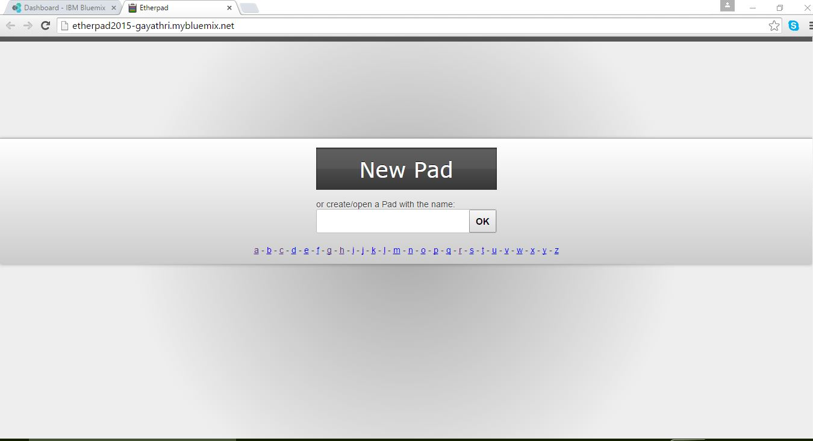

Give a name to open the PAD

1. Now, run Etherpad and test it!

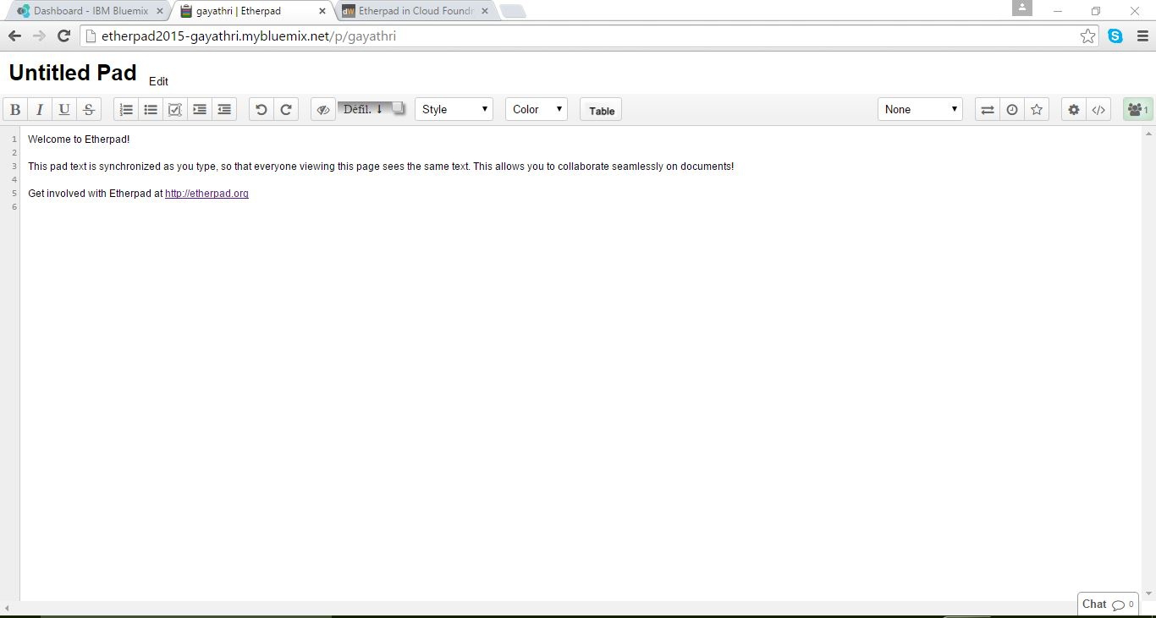

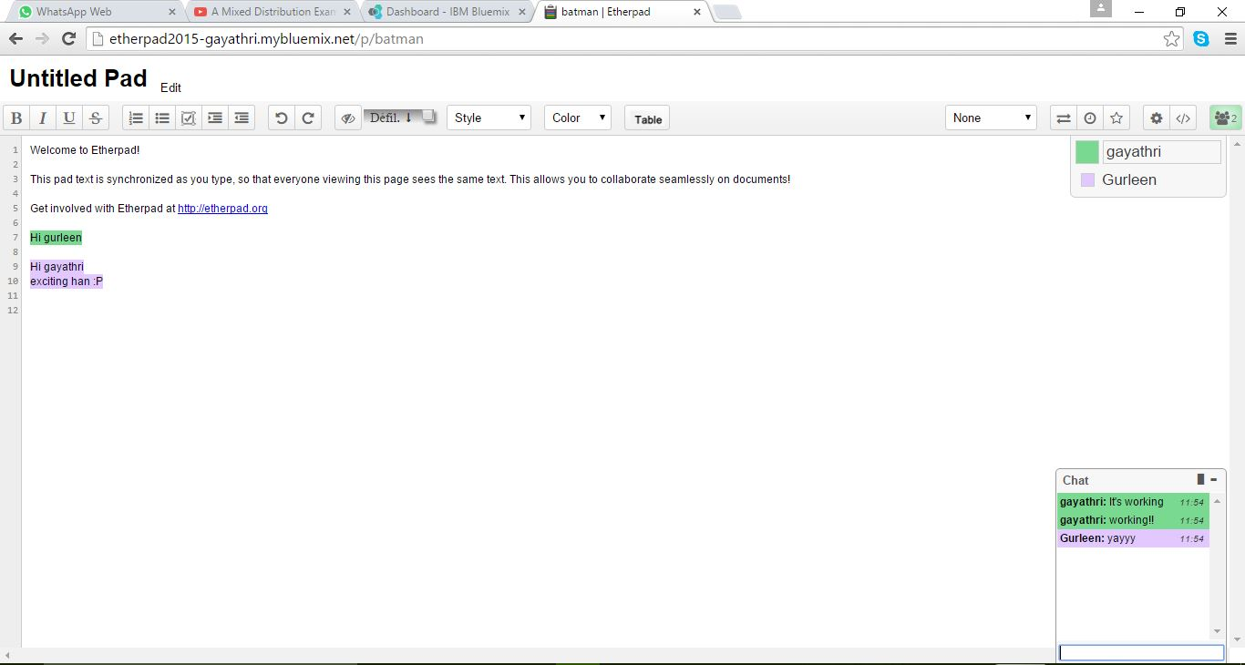

We have successfully tested it and it works!

Problems faced during installation of app:

Error message:

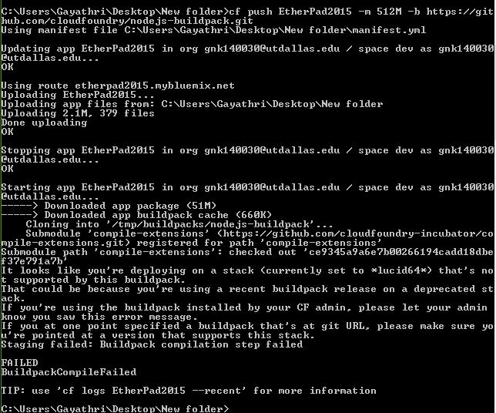

The reason why it showed a “FAILED” error message was that, the etherpad-lite-cf.zip was not installed properly. The contents of the folder were not uploaded to the cloud properly. When you re-install and unzip the files properly, and push it to your app, it works fine.

**Team:**

*Team – 22:*

Gurleen Chawla and Gayathri N Kannepalli